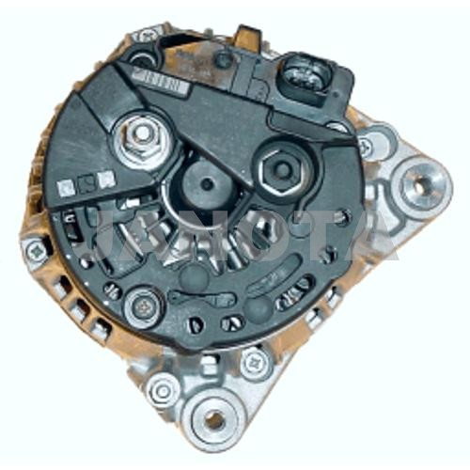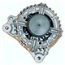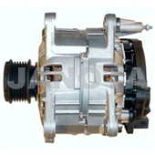

0124515010 BOSCH 120A
0124515117 BOSCH 120A
0124515121 BOSCH 180A
0124515124 BOSCH 180A
0124515125 BOSCH 180A
028903028E BOSCH 120A
028903029G HITACHI
028903030 VALEO 120A
038903018Q VALEO 120A
038903023S VALEO 120A
038903024F VALEO 120A
2542237
2542237A
2542237D
2542461
2542461A
98VW-10300-EA
LR1120-701
SG12B015 180A
SG12B090
VALEO TECH 2579147 180A

SKODA - EUROPE CAR FABIA 1400, AMF 2003-2007
SKODA - EUROPE CAR FABIA 1400, BMS BNV 2005-2010
SKODA - EUROPE CAR FABIA 1400, BNM 2005-2010
SKODA - EUROPE CAR FABIA 1422CCM AMF, 1.4 TDI 2003-2007
SKODA - EUROPE CAR FABIA 1422CCM BNM, 1.4 TDI 2005-2007
SKODA - EUROPE CAR FABIA 1422CCM BNV, 1.4 TDI 2005-2007
SKODA - EUROPE CAR FABIA 1896CCM ASY, 1.9 SDI 1999-2015
SKODA - EUROPE CAR FABIA 1896CCM ASZ, 1.9 TDI RS 2003-2015
SKODA - EUROPE CAR FABIA 1896CCM ATD, 1.9 TDI 1999-2015
SKODA - EUROPE CAR FABIA 1896CCM BLT, 1.9 TDI 2003-2015
SKODA - EUROPE CAR FABIA 1900, ASY 2000-2006
SKODA - EUROPE CAR FABIA 1900, ATD AXR 2000-2007
SKODA - EUROPE CAR FABIA 1900, BLS BSW 2007-2010
SKODA - EUROPE CAR FABIA 1900, VRS, ASZ BLT 2003-2008
SKODA - EUROPE CAR FABIA 2000, AZL 2000-2007
SKODA - EUROPE CAR FABIA II 1422CCM BMS, 1.4 TDI 2007-2010
SKODA - EUROPE CAR FABIA II 1422CCM BNM, 1.4 TDI 2007-2010
SKODA - EUROPE CAR FABIA II 1422CCM BNV, 1.4 TDI 2007-2010
SKODA - EUROPE CAR OCTAVIA 1595CCM AVU, 1.6 2000-2002
SKODA - EUROPE CAR OCTAVIA 1598CCM AEH, 1.6 2000-2015
SKODA - EUROPE CAR OCTAVIA 1598CCM ALK, 1.6 2000-2015
SKODA - EUROPE CAR OCTAVIA 1598CCM AVU, 1.6 2000-2002
SKODA - EUROPE CAR OCTAVIA 1598CCM BFQ, 1.6 2000-2015
SKODA - EUROPE CAR OCTAVIA 1600, AEH AKL AVU BFQ 1998-2004
SKODA - EUROPE CAR OCTAVIA 1781CCM AGU, 1.8 T 1998-2004
SKODA - EUROPE CAR OCTAVIA 1781CCM AUM, 1.8 T 2000-2004
SKODA - EUROPE CAR OCTAVIA 1781CCM AUQ, 1.8 T 2000-2015
SKODA - EUROPE CAR OCTAVIA 1800, TURBO 2000-2004
SKODA - EUROPE CAR OCTAVIA 1896CCM AGP, 1.9 SDI 1998-2000
SKODA - EUROPE CAR OCTAVIA 1896CCM AGR, 1.9 TDI 1998-2006
SKODA - EUROPE CAR OCTAVIA 1896CCM ASZ, 1.9 TDI 2000-2004
SKODA - EUROPE CAR OCTAVIA 1896CCM ATD, 1.9 TDI 2000-2004
SKODA - EUROPE CAR OCTAVIA 1896CCM AXR, 1.9 TDI 2005-2015
SKODA - EUROPE CAR OCTAVIA 1900, AGP 1999-2000
SKODA - EUROPE CAR OCTAVIA 1900, AGR AHF ALH ASV AXR 1998-2010
SKODA - EUROPE CAR OCTAVIA 1900, AQM 2000-2003
SKODA - EUROPE CAR OCTAVIA 1900, ASZ 2003-2004
SKODA - EUROPE CAR OCTAVIA 1984CCM AEG, 2.0 1999-2002
SKODA - EUROPE CAR OCTAVIA 1984CCM APK, 2.0 1999-2002
SKODA - EUROPE CAR OCTAVIA 1984CCM AQY, 2.0 1999-2002
SKODA - EUROPE CAR OCTAVIA 1984CCM AZH, 2.0 1999-2002
SKODA - EUROPE CAR OCTAVIA 1984CCM AZJ, 2.0 1999-2002
SKODA - EUROPE CAR OCTAVIA 2000 2000-2004
SKODA - EUROPE CAR ROOMSTER 1400, BMS BNV 2006-2010
SKODA - EUROPE CAR ROOMSTER 1400, BNM 2006-2010
SKODA - EUROPE CAR ROOMSTER 1422CCM BMS, 1.4 TDI 2006-2010
SKODA - EUROPE CAR ROOMSTER 1422CCM BNM, 1.4 TDI 2006-2010
SKODA - EUROPE CAR ROOMSTER 1422CCM BNV, 1.4 TDI 2006-2010
SKODA - EUROPE CAR ROOMSTER 1896CCM AXR, 1.9 TDI 2006-2010
SKODA - EUROPE CAR ROOMSTER 1896CCM BLS, 1.9 TDI 2006-2010
SKODA - EUROPE CAR ROOMSTER 1896CCM BSW, 1.9 TDI 2006-2010
SKODA - EUROPE CAR ROOMSTER 1900, AXR BLS BSW 2006-2010
SKODA - EUROPE CAR ROOMSTER PRAKTIK 1422CCM BMS, 1.4 TDI 2007-2010
SKODA - EUROPE CAR ROOMSTER PRAKTIK 1422CCM BNM, 1.4 TDI 2007-2010
SKODA - EUROPE CAR ROOMSTER PRAKTIK 1422CCM BNV, 1.4 TDI 2007-2010

