

ETKA

|  |  |  |  |  |  |  |  |  |
| --- | --- | --- | --- | --- | --- | --- | --- | --- |
| Model  OCT | Year  2003 | MG  1 | SG  45 | Illustration  145-50 | Restrictions | UPD  133 | 19:25 | 21.04.2022 |
|  | |

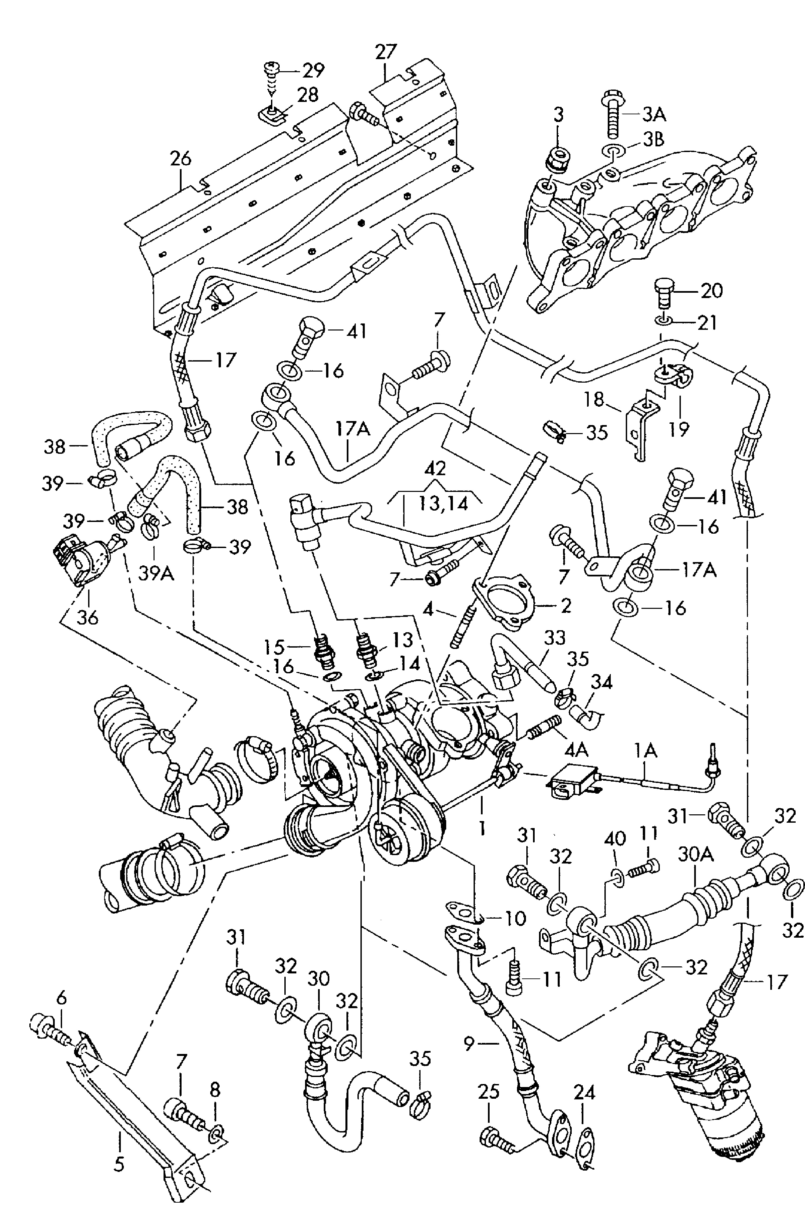

et_bild.frm

EPIS 252